Hospice Vehicle Maintenance

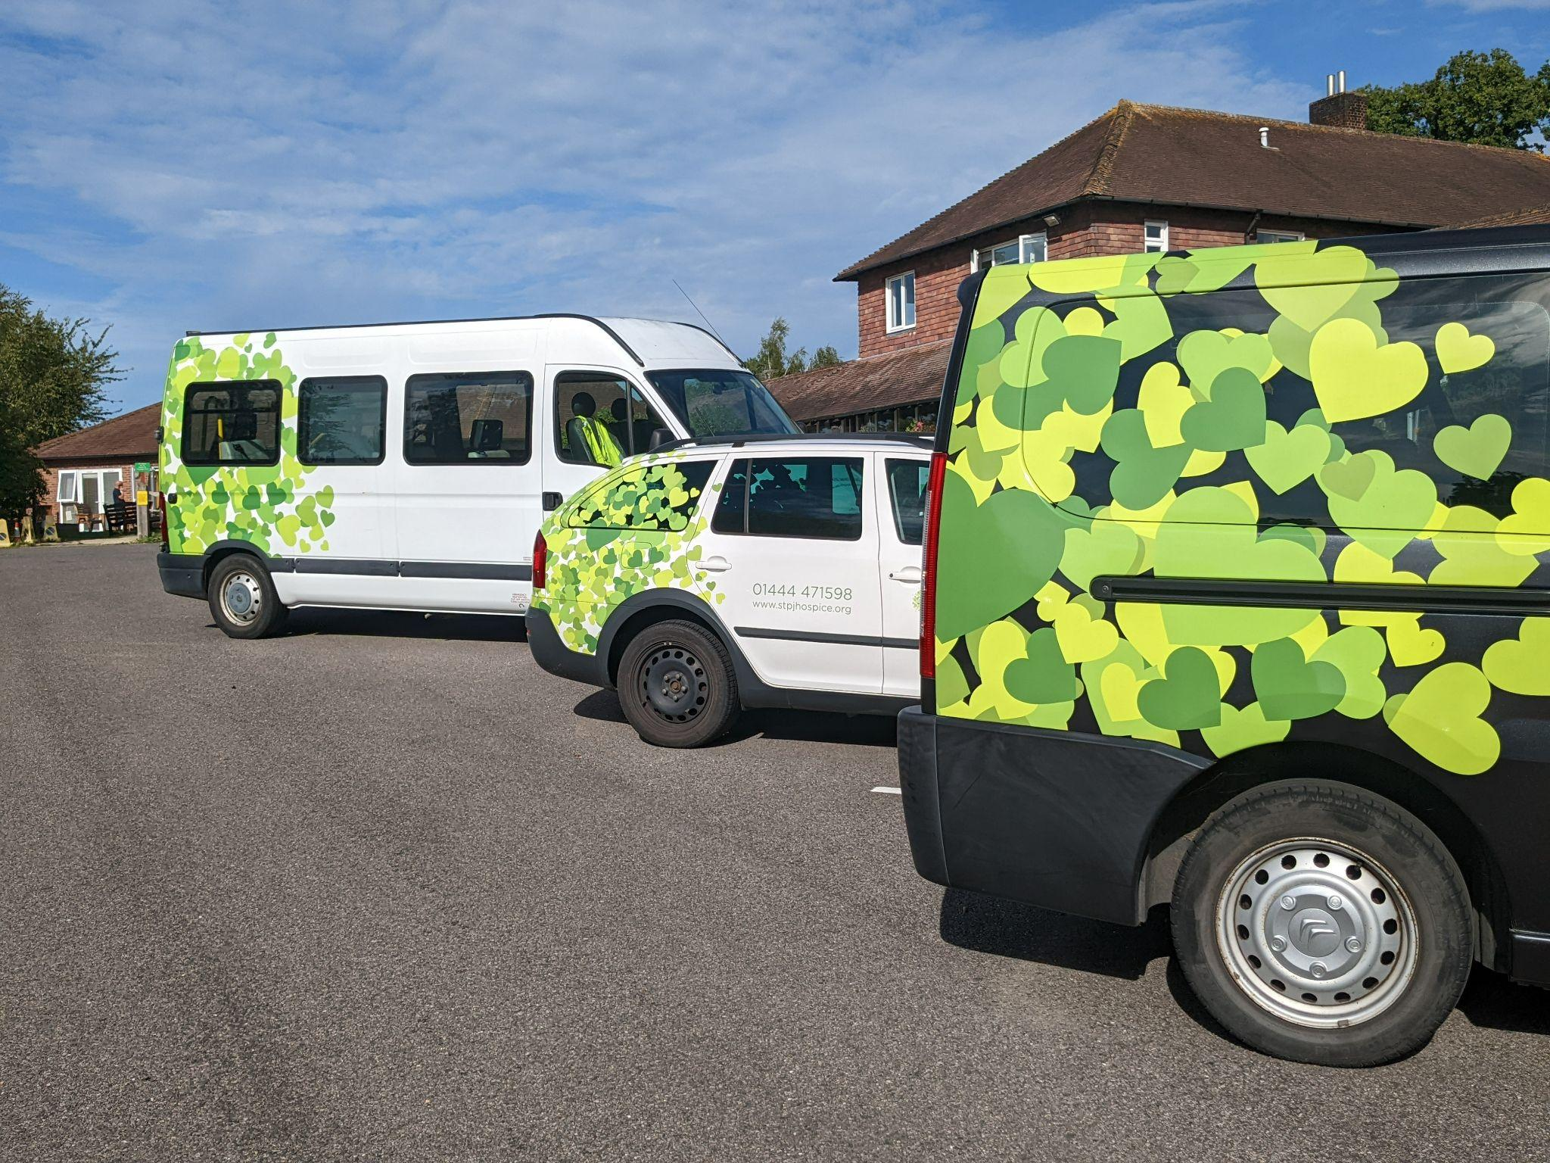
Position | Hospice Vehicle Maintenance Volunteer
Department | Facilities and Estates Department

VISION, MISSION AND VALUES
Our Vision
A community where people live and die well according to what matters most to them.
Everyone affected by life-limiting illness has access to our expertise.
Our Mission
Providing the right care, in the right place, at the right time, to everyone who needs us.
Our Values
They are at the heart of our organisation and underpin all that we do. They define who we are, how we work, what we believe in and stand for.
- Compassion - We show everyone empathy, kindness and respect.
- Integrity - We do the right thing, no matter how challenging.
- Accountability - We take responsibility for our actions and outcomes.
- Excellence - We strive to be outstanding and aim to exceed expectations.
- Inclusivity - We welcome and respect everyone.
ROLE PURPOSE
The Hospice is set on 36 acres of stunning grounds with landscaped gardens, flower beds and natural woodland. The hospice itself incorporates our In-Patient Unit (IPU), administration offices and housekeeping. Additionally, we have two minibuses to transport our visitors and patients.
WHAT WILL I BE DOING?
- Vehicle Maintenance - Check petrol, screen wash, tyres pressure and tread, lights working, seat belts and straps correct
- Valeting Vehicle - Clean vehicle inside and out,
- Administration Checks - check daily paperwork completed and driver paperwork all ready for the week
- First Aid Kit Maintenance - Check and replenish first aid kit
- Liaising with Property Manager
WHAT SKILLS DO I NEED?
- An interest and understanding of vehicle maintenance
- Good physical fitness
- A clean driving licence
- Friendly and approachable
- Committed and reliable
WHAT ELSE DO I NEED TO KNOW?
- Communicate regularly with the Property Manager
- Please do not lift any heavy objects that you are not comfortable with
- Please do not repair any equipment but report to the Property Manager
- Demonstrate hospice values
- Please note there is no available public transport to the hospice site

WHAT TRAINING MUST I DO?
- Hospice Induction training
- Face to face driving assessment with Property Manager
- Training on how to use the vehicles tailgate on the minibus
- Face-to-face training when required
WHEN WILL I BE NEEDED?
Flexible depending on availability

WHERE WILL I BE VOLUNTEERING?
St Peter and St James Hospice
North Common Road
North Chailey
Haywards Heath
West Sussex
BN8 4ED
WHO WILL BE MY SUPERVISOR?
Gavin Carby, Property Manager

